**Japanese Math Problem**

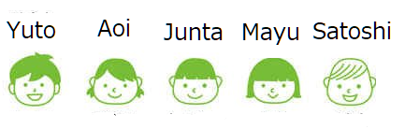

Five Japanese children, Yuto, Aoi, Junta, Mayu, and Satoshi, go to the same school. However, they are not in the same grade; they are from grade 2 to grade 6. Their favorite sports are also different: tennis, baseball, soccer, swimming, and jumping rope.

* The child who is in the fifth grade loves swimming.
* The child who is in the fourth grade is not good at soccer.
* Yuto is two grades above Mayu.
* Junta is good at baseball and is three grades lower than Aoi.
* Satoshi’s friend is in the fourth grade and is good at tennis.
* Mayu is one grade above the child who is good at jumping rope.

Who is in what grade as well as what in the child's favorite sport?

|  |  |  |
| --- | --- | --- |
|  | Grade | Favorite Sport |
| Yuto |  |  |
| Aoi |  |  |
| Junta |  |  |
| Mayu |  |  |
| Satoshi |  |  |

この英訳は「 算数と国語を同時に伸ばすパズル（小学館：宮崎哲也著）」から引用しています。