**Japanese Math Problem**

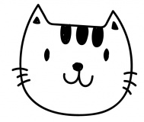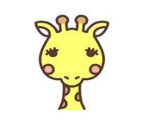

**A**

**B**

**F**

**E**

**C**

**D**

* The dog says, “The elephant is next to me.”
* The cat says, “The lion is in front of me.”
* The rabbit says, “The cat is not next to me.”
* The elephant says, “The rabbit is not next to me.”
* The lion says, “The dog is not in front of me.”
* The giraffe says, “The elephant is in front of me.”

|  |  |
| --- | --- |
| Seat Number | Animal |
| A | Dog |
| B |  |
| C |  |
| D |  |
| E |  |
| F |  |

この英訳は「 算数と国語を同時に伸ばすパズル（小学館：宮崎哲也著）」から引用しています。