**Japanese Math Problem**

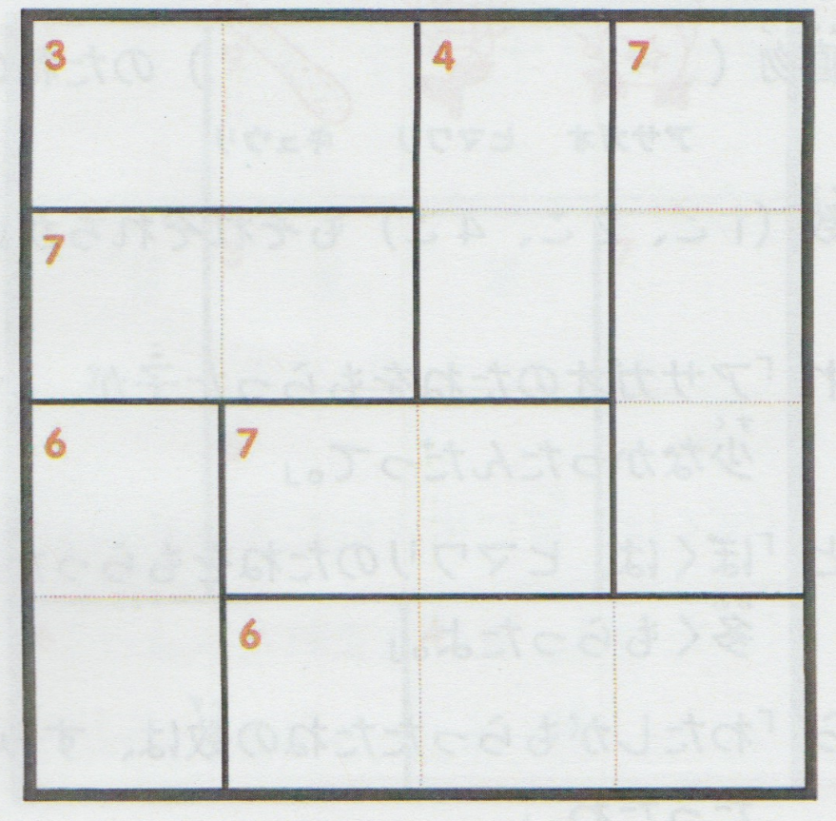

1. Put the numbers from 1 to 4 in each square above.
2. The numbers from 1 to 4 can be used only once in each column or row.
3. The number in each rectangle should be the sum of the numbers in the squares that make up the rectangle.

Sample:

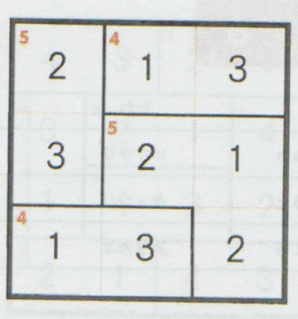

この英訳は「 算数と国語を同時に伸ばすパズル（小学館：宮崎哲也著）」から引用しています。